**Your Task:**This assignment is divided into two main sections:

1. Demonstrating your ability to use Conestoga’s library databases; and
2. Reflecting on the process of using Conestoga’s library databases.

Follow the steps in order and provide your responses in the boxes provided.

**Section 1: Demonstration**

In this section, you will use screen captures / screen grabs and written descriptions todemonstrate your ability to effectively use Conestoga’s library databases.

1. **Choose a Topic:**Pick onereading from earlier in the semester that you are interested in learning more about.**Write a reference forthis reading, using the appropriate style guide, in the space below.**

Next, choose a research topic or theme inspired by this reading. This topic or theme can be closely related to your chosen reading, or you can try to develop a new topic or theme that expands on the original one. **Write the topic or theme that you have chosen in the space below.**

|  |
| --- |
| **Reading (1 point)**:  Paul, W. (n.d.). *The Future is Virtual*. Shibboleth authentication request. Retrieved October 30, 2021, from  <https://web-s-ebscohostcom.conestoga.idm.oclc.org/ehost/detail/detail?vid=0&sid=f3341a7f-d525-4523-ab7e-6a769dbfacb4%40redis&bdata=JnNpdGU9ZWhvc3QtbGl2ZSZzY29wZT1zaXRl#AN=146898990&db=rch>. |
| **Topic / Theme (1 point)**:  “ How remote working and studying influence in future?” |

1. **Find a Relevant Text:**Use Conestoga’s library database to find a text that willhelp you to learn more about the topic or theme that you have chosen.

Follow these steps to add screen captures grabs

1. Click on the relevant box.
2. Select “Insert” from the menu above.
3. Click “Pictures.”
4. Click “Insert Picture from This Device.”
5. Select the relevant screen grab.
6. **KEYWORDS (2 points)**In the box below, include a picture of the keywords that you used to find a relevant text on your topic.

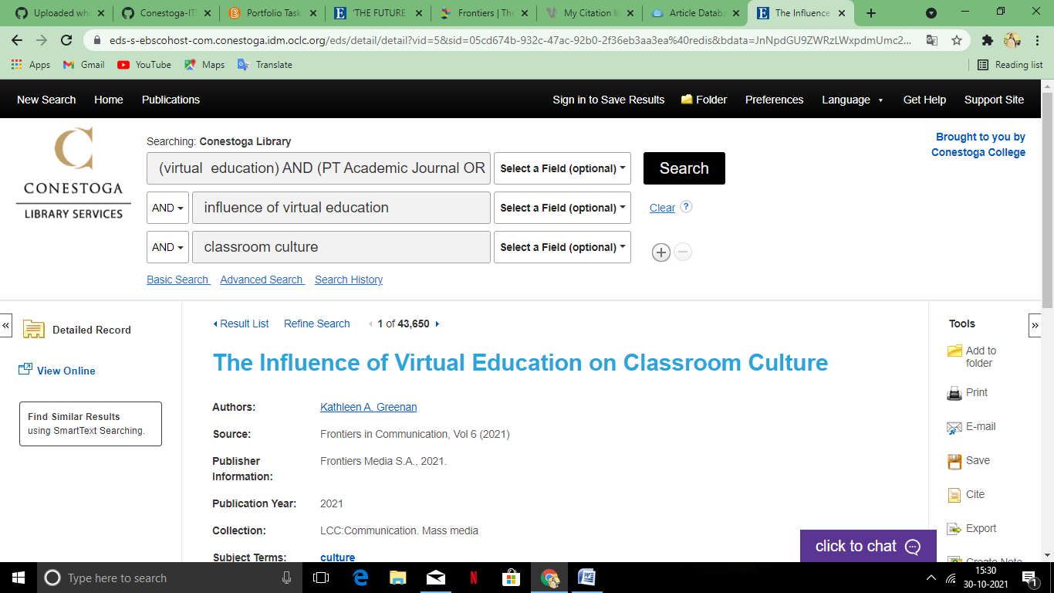

In the box below, explain how you chose these keywords. If you began your search with different keywords or added to your initial keywords, discuss that change in your explanation.

|  |
| --- |
| Firstly, I used the “virtual” keyword to search the topic which I chose, but there were millions of article of that word. Then, I changed my keyword to “virtual education”. And after that, to get the specific article I select “and’ to add the additional details “influence of virtual education” and then again press “and” and add “classroom culture”. |

1. **LIMITERS (2 points)**

In the box below, include a picture of the limiters (e.g. publication date, source type) that you used to find a relevant text on your topic.

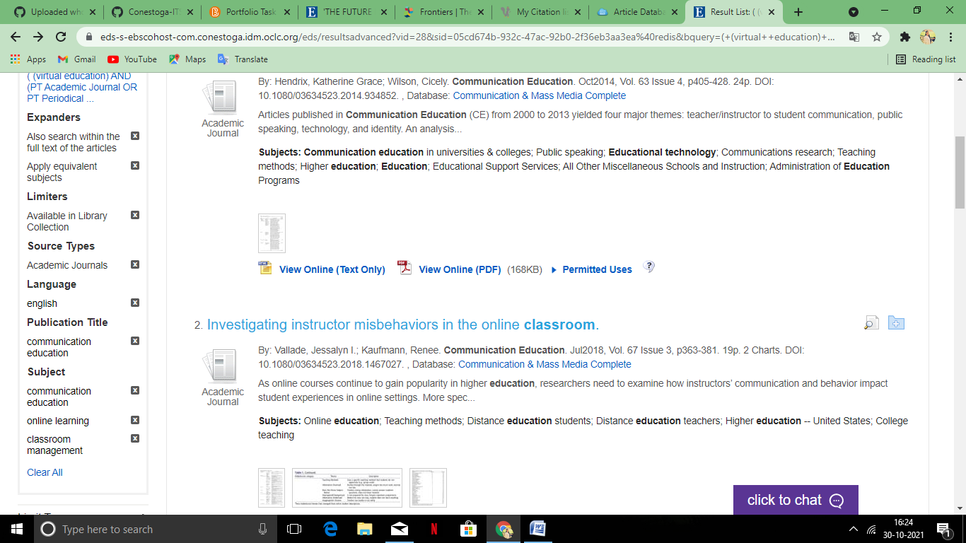

In the box below, explain why you chose these limiters and how they helped you to find a relevant text on your topic.

|  |
| --- |
| In the beginning , I select the “source type” and add “Academic Journals” make my search more specific . Then make it more definite I select “Publication Title “ and that makes my search list more narrow and then by adding “ Subject” to it that make my search completely visible. |

1. **BIBLIOGRAPHIC DETAILS (2 points)**

In the box below, include a picture of the bibliographic details (e.g. date of publication, name of publication, title) that appear on the “Detailed Record” of your chosen text.

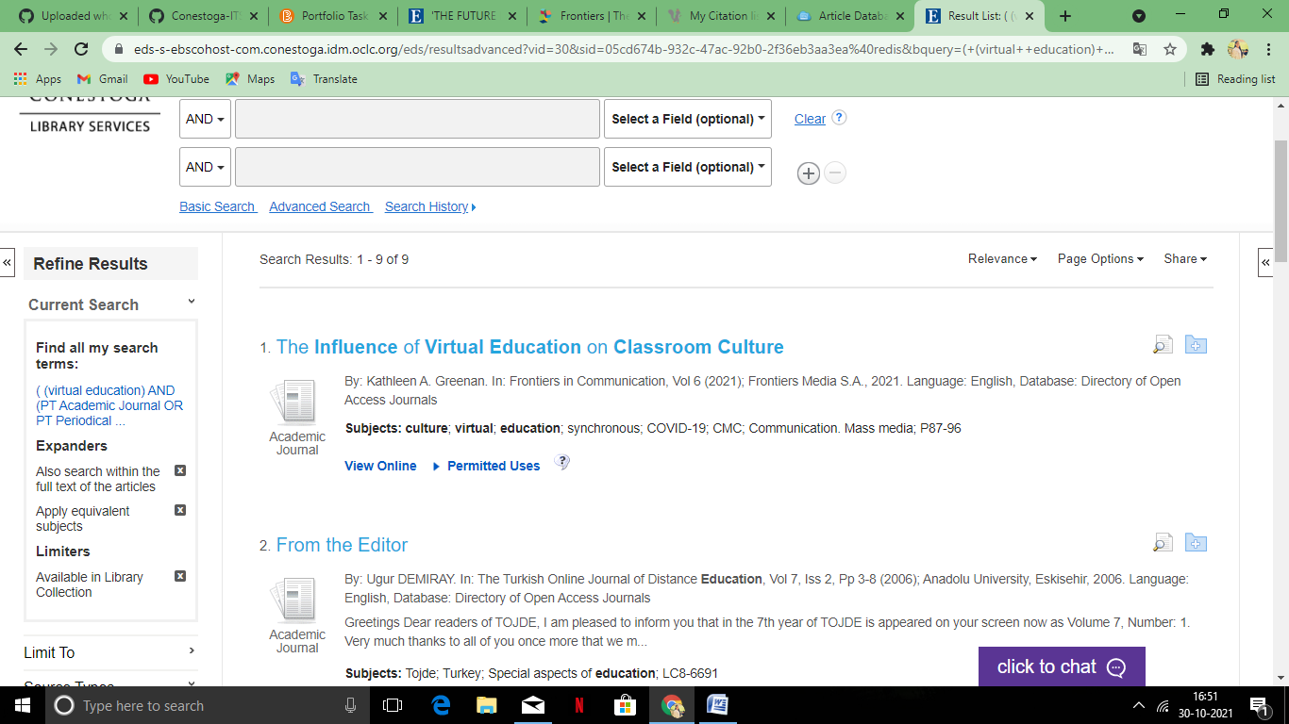

In the box below, explain how these bibliographic details help you to know that thetext you have chosen is relevant to your search.

|  |
| --- |
| This article's title, "The Influence of Virtual Education on Classroom Culture," seemed eerily similar to the theme of "Future is Virtual." I felt better when I saw the publication date and year of this article because it has an impact on the current situation. I had to Google the magazine's name since I didn't remember it, but I was pleased to learn that it was a literary publication focused on distant education and work. That sounded like an excellent resource for this subject. |

1. **SUBJECT KEYWORDS (2 points)**

In the box below, include a picture of the subject keywords or “tags” located at the bottom of the search result (or in the “Detailed Record”), under the boldface heading

“Subjects.”



In the box below, explain how these subject keywords / tags help you to know that thetext you have chosen is relevant to your search.

|  |
| --- |
| "Culture," "Virtual," and "Education" were the subject keywords that gave me hope in this text. These all seemed quite similar to my initial research topic, as well as the topic of "Future is Virtual," which had gotten me thinking about this topic in the first place. There were no other subject keywords irrelevant to my issue, and some of the other books I was evaluating had subject keywords that led me to believe the reading was only partially about my topic. |

1. **ABSTRACT / SUMMARY (2 points)**

In the box below, include a picture of the abstract or summary located at the bottom of the “Detailed Record,”beneath the bibliographic details.

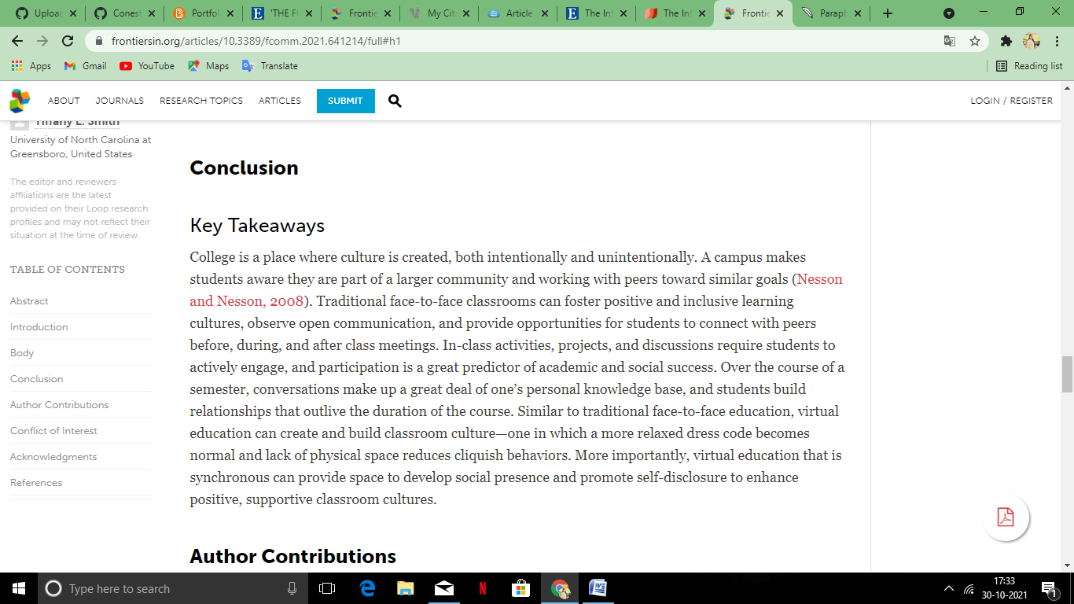

In the box below, explain how this abstract or summary helps you to know that thetext you have chosen is relevant to your search.

|  |
| --- |
| The summary of this article is somewhere similar to the article which I chose. And that made me more believable about this article. |

**Section 2: Reflection**In this section, you will discuss your chosen text and reflect on the process of finding it.

1. **Identify the Text(2 points)**  
   In the space below, provide a reference (in the appropriate academic style) for the text you found in the library.   
     
   *Note: this should not be the same text that you listed above in Section 1-A.*

|  |
| --- |
| Greenan, K. A. (1AD, January 1). *The influence of virtual education on classroom culture*. Frontiers. Retrieved October 31, 2021, from  <https://www.frontiersin.org/articles/10.3389/fcomm.2021.641214/full>. |

1. **Justify Your Choice(2 points)**  
   Explain why the text you have found represents a relevant source of information and/or ideas on your chosen topic?

In other words, what does this text add to your understanding of the topic, and why is this text in particular a good fit for you, as opposed to some other text on the same topic?

|  |
| --- |
| “The influence of virtual education on classroom culture” is so similar to the topic which I chose “The Future is Virtual”. In that topic there shows the social challenges of using virtual technology during the execution of lockdown protocols in Canada as a result of the corona virus disease 2019 (COVID-19) pandemic The difference between viewing movies at home and going to the movies, the move to online learning and remote work, and the need for people to engage with others face-to-face are all discussed, which is quite similar to the topic I found here, which says” More crucially, synchronous virtual education can give a platform for students to establish social presence and foster self-disclosure, resulting in more pleasant and supportive classroom environments.” |

1. **Reflect on the Challenge(2 points)**

How easy or difficult did you find the process of using the library database?

Explain any challenges you faced and how you overcame them.

|  |
| --- |
| When I didn't get any decent results after limiting my search to what was available in the library collection, I was a little dismayed. I also utilised the "source type" restriction to narrow down my search to a certain article. However, I then removed the "source type" limiting and replaced it with the "subjects" limiter. This was useful since it made me understand that my search results had a lot of content that had nothing to do with my topic and that I needed to narrow down my search. |

1. **Extend Your Knowledge(2 points)**

When you proceed with the research project after Student Success week, what skills, strategies, or concepts will you take with you from this task?

In other words, what have you learned that will help you make the most of the library’s databases on the upcoming Research Project?

|  |
| --- |
| This library search taught me a lot of things. Yes, at first I felt it was a more difficult and time-consuming process than an internet search. However, after I understood how the limiters work, it became much easier for me to locate the specific article that is so similar to the one I chose. I can confidently state that this library search will assist me with my future study project. |